Retail Sales Analytics and Customer Intelligence Framework Using Machine Learning and Business Intelligence
Sri Hansika, J. Madhura, R. Lokesh, G. Charan
Department of Computer Science and Engineering, K L University, Hyderabad, India
Data Analytics and Visualization (24DSB3101)

ABSTRACT
The retail industry generates large volumes of transactional data containing information about customers, products, sales, quantities, discounts, profits, shipping, and geographical regions. Although such data contains valuable information, conventional reporting systems often focus mainly on historical summaries and do not provide an integrated approach for predictive analysis and customer intelligence. This research presents a Retail Sales Analytics and Customer Intelligence Framework Using Machine Learning and Business Intelligence to transform retail transaction data into meaningful and actionable insights.
The proposed framework integrates data preprocessing, exploratory data analysis, statistical analysis, feature engineering, feature selection, machine learning, customer segmentation, RFM analysis, Customer Lifetime Value analysis, SQL-based data processing, scenario analysis, and Power BI visualization. The implemented system uses the Global Superstore dataset containing 51,290 transaction records, 1,590 customers, 25,035 orders, and 10,292 products. Four regression algorithms, namely Linear Regression, Decision Tree, Random Forest, and XGBoost, are evaluated for sales prediction using Mean Absolute Error, Root Mean Squared Error, and R². K-Means clustering is applied for customer segmentation and evaluated using the Silhouette Score.
The experimental results show that XGBoost obtains an MAE of 32.8537, RMSE of 57.0368, and R² of 0.9116 on the test dataset. K-Means obtains its highest Silhouette Score of 0.666635 for two clusters. RFM analysis identifies High Value, Medium Value, and Low Value customers, while the CLV module provides an additional customer-value perspective. Scenario analysis is also performed to investigate model-based changes in predicted sales under different discount and quantity conditions. Finally, Power BI dashboards integrate the analytical outputs into interactive business intelligence views.
The major contribution of the framework is the integration of predictive analytics and customer intelligence with business intelligence and a proposed Business Recommendation Engine. The framework provides a complete pipeline from raw retail data to predictive results, customer insights, interactive dashboards, and decision-support information.
Keywords: Retail Analytics; Customer Intelligence; Sales Prediction; Machine Learning; XGBoost; K-Means; RFM Analysis; Customer Lifetime Value; Power BI; Business Intelligence

1. INTRODUCTION
1.1 Background
The retail industry has undergone significant transformation due to the increasing availability of digital transaction data. Retail organizations continuously generate information through customer purchases, product transactions, sales, discounts, quantities, profits, shipping records, and regional operations. Such data provides an opportunity to understand customer behavior, evaluate product performance, identify profitable regions, and improve sales planning. However, raw transaction data cannot directly provide useful business information. It must first be cleaned, transformed, analyzed, and interpreted.
Traditional retail reporting generally concentrates on descriptive statistics and historical business performance. Reports may provide total sales, total profit, product performance, and regional performance, but these reports often do not provide predictive capabilities. Modern retail analytics requires a combination of descriptive, diagnostic, predictive, and business intelligence techniques.
Machine learning provides an opportunity to extend retail analytics beyond historical reporting. Regression algorithms can be used to estimate sales, while clustering algorithms can identify groups of customers with similar purchasing behavior. RFM analysis provides customer-level measures based on Recency, Frequency, and Monetary value. Customer Lifetime Value provides another perspective by estimating the historical value associated with individual customers.
The project therefore proposes an integrated analytics framework rather than a single predictive model. The project roadmap includes data collection, preprocessing, EDA, statistical analysis, feature engineering, machine learning, SQL, visualization, Power BI dashboards, and business insights as interconnected stages.

1.2 Problem Statement
Retail datasets contain extensive information about sales, customers, products, profits, discounts, and regions. However, analyzing these variables independently can make it difficult to obtain a complete understanding of retail performance.
Existing analytical approaches may focus primarily on sales forecasting, customer segmentation, RFM analysis, or dashboard visualization. A lack of integration between these components can reduce the usefulness of the analytical results for business decision-making.
The problem addressed in this research is therefore:
How can an integrated retail analytics framework combine data preprocessing, exploratory analysis, machine learning, customer segmentation, customer-value analysis, SQL, scenario analysis, and business intelligence to transform retail transaction data into actionable business insights?

1.3 Research Gap
The project review identifies several gaps in existing retail analytics research:
- Limited end-to-end integration of Data Analytics, Machine Learning, SQL, and Business Intelligence.
- Limited integration of customer and product intelligence with sales prediction.
- Limited systematic comparison of multiple machine-learning models.
- Limited conversion of analytical results into actionable recommendations.
- Limited use of Explainable AI for interpreting machine-learning-based retail insights.
The proposed framework addresses these gaps by integrating multiple analytical components into one workflow.

1.4 Research Objectives
- The objectives of the proposed research are:
- To develop an end-to-end retail analytics framework integrating Python, data preprocessing, EDA, machine learning, SQL, and Power BI.
- To analyze sales, customer, product, profit, discount, and regional behavior.
- To develop and compare multiple machine-learning models for sales prediction.
- To perform customer segmentation using K-Means clustering.
- To perform RFM-based customer-value analysis.
- To calculate Customer Lifetime Value using historical customer behavior.
- To develop interactive Power BI dashboards for retail business analysis.
- To perform model-based scenario analysis for discount and quantity variations.
- To design a Business Recommendation Engine that converts analytical outputs into business-oriented recommendations.
- The project documentation identifies the same core objectives, including end-to-end analytics, customer and product behavior analysis, machine-learning evaluation, dashboards, and a business recommendation module.

1.5 Research Questions
- RQ1: How do Linear Regression, Decision Tree, Random Forest, and XGBoost perform for retail sales prediction?
- RQ2: What number of clusters provides the most appropriate customer segmentation according to the Silhouette Score?
- RQ3: How does RFM analysis complement machine-learning-based customer segmentation?
- RQ4: How can Customer Lifetime Value provide additional information about customer value?
- RQ5: How can interactive Power BI dashboards transform analytical results into business intelligence?
- RQ6: How can scenario analysis connect machine-learning predictions with business-oriented decision support?

1.6 Contributions
- Development of an integrated retail analytics architecture.
- Comparative evaluation of four sales-prediction algorithms.
- Customer segmentation using K-Means.
- RFM-based customer-value analysis.
- Customer Lifetime Value analysis.
- SQL-based data storage and querying.
- Interactive Power BI business intelligence dashboards.
- Model-based scenario analysis.
- Proposed Business Recommendation Engine.
1.7 Organization of the Paper
The first section explains the research background, problem, gap, objectives, research questions, and contributions of the research. The second section provides an overview of the research related to retail analytics, machine learning, customer segmentation, RFM analysis, and business intelligence. The third section explains the research methodology and system architecture. The fourth section explains the experimental setup, dataset, tools used, modeling technique, validation process, and performance metrics. The fifth section presents the results of the experiments through tables, graphs, customer analysis, scenario analysis, and the output of the Power BI dashboard. The sixth section discusses the results of the experiment and the practical applications thereof. The seventh section discusses the limitations of the research.
2. RELATED WORK
2.1 Existing Approaches
Typically, retail analytics includes descriptive statistics, sales consolidation, customer analysis, product analysis, and geographical analysis. Using such approaches, companies can learn about their past performance in business.

But, descriptive analytics is not sufficient for predicting the future performance of sales or customers. Machine learning can help to continue the analytics process by finding nonlinear dependencies within the transactional data.
2.2 Machine Learning / Computational Approaches
Regression algorithms are widely applied in numerical forecasting problems. Linear Regression serves as a simple starting point to study linear dependency between input variables and sales. Decision Trees apply nonlinear decision-making procedures. The Random Forest method applies several decision trees for variance reduction, while XGBoost employs gradient boosting in order to create an ensemble of decision trees.

The suggested research studies the performance of all four approaches on the same dataset and the same test split.
2.3 Advanced / Alternative Approaches
Customer Segmentation involves segregating the customers on the basis of similarities in purchase behavior. The use of clustering algorithms is beneficial because they don’t need pre-existing customer labels.

The K-Means algorithm is probably the most popular clustering technique. Customers are segregated on the basis of closeness to the cluster centroids.

The RFM model offers another customer segmentation technique. RFM stands for:
Recency – How recent was the last purchase of the customer?
Frequency – How often did the customer make purchases?
Monetary – How much money did the customer spend?
There have been many studies regarding the use of machine learning and clustering techniques in retail customer segmentation. John, Shobayo, and Ogunleye compared different clustering algorithms through RFM customer features and found differences in clustering effectiveness.
Wang, Sun, and Yu developed a dynamic customer segmentation model by combining LRFMS with multivariate time-series clustering. It highlights the significance of modeling customer behavior dynamicalle.
2.4 Explainability / Interpretability (or other relevant sub-theme)
Kasem, Hamada, and Taj-Eddin conducted research in customer profiling, segmentation, and sales prediction through artificial intelligence in direct marketing. The research shows how useful it is to integrate the use of customer profiling and prediction in marketing analytics.
Tang studied retail demand forecasting and customer classification through regression techniques and RFM analysis. This gives an example of how sales prediction and customer segmentation can be integrated in retail analytics.
It can therefore be seen that while it is possible to apply machine learning and customer analytics in retail, different researches tend to focus on different parts of the whole analytics process.
2.5 Critical Comparison
The study by Kasem, Hamada, and Taj-Eddin involves customer profiling, segmentation, and sales predictions using artificial intelligence in direct marketing. This study is an example of the importance of combining the use of customer profiling and sales prediction in marketing analytics.
Tang researched retail demand forecasting and customer classification using regression methods and RFM analysis. This study provides an example of the integration of sales prediction and customer segmentation in retail analytics.
It can therefore be deduced that although machine learning and customer analytics are applicable in retail, different studies have concentrated on different aspects of the whole analytics process..
# | Study / Publication | Key Contribution | Limitation
1 | Ulocking Retail Insights: Predictive Modeling and Customer Segmentation Through Data Analytics | Predictive modeling and customer segmentation | Limited BI, SQL, and actionable recommendation integration
2 | Predictive Modeling and Customer Segmentation Using ML | ML model comparison for sales forecasting | Limited customer intelligence and BI integration
3 | Customer Profiling, Segmentation, and Sales Prediction Using AI in Direct Marketing | Customer profiling, segmentation and sales prediction | Limited product, regional and BI integration
4 | A Dynamic Customer Segmentation Approach by Combining LRFMS and Multivariate Time Series Clustering] | Dynamic customer segmentation | Limited sales prediction and broader BI integration
5 | A Comprehensive Framework for Customer Segmentation and Predictive Analytics | Customer segmentation and predictive analytics | Limited SQL, Power BI and automated recommendations
.
2.6 Research Gap (Summary)
The reviewed literature shows the importance of using machine learning, clustering, RFM analysis, and customer profiling. But there is still a need for an integrated approach that includes sales prediction, customer segmentation, customer value analysis, SQL, visualization, and business insights.
The suggested approach satisfies the need through creating an analytical pipeline:
Data → Data Preprocessing → Exploratory Data Analysis → Feature Engineering → Machine Learning → Customer Intelligence → SQL → Power BI → Scenario Analysis → Business Insights.
3. PROPOSED METHODOLOGY
3.1 Overall Framework
proposed methodology follows an end-to-end architecture that converts raw retail transactions into analytical and business intelligence outputs..

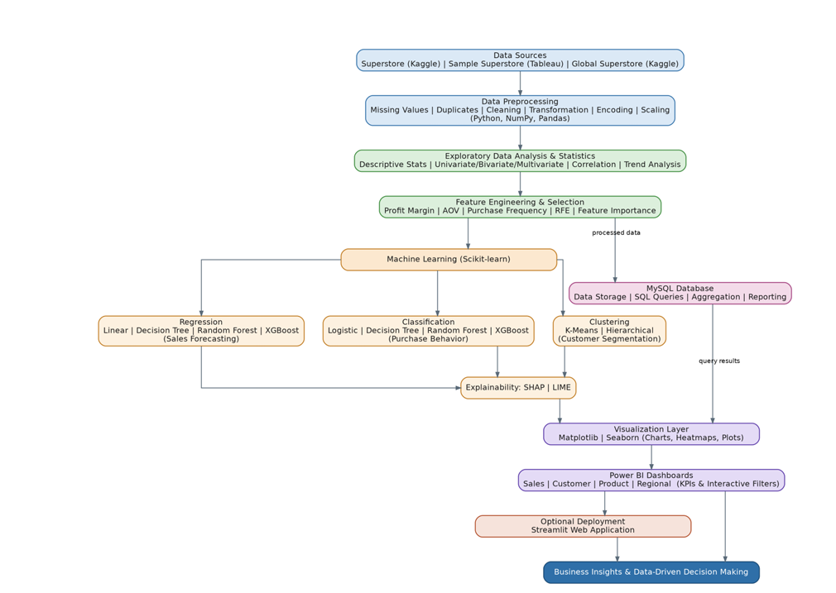
Fig. 1.The roadmap provided for the project includes an integrated pipeline process starting from data sources to visualization using Power BI and MySQL along with various other steps such as machine learning..
3.2 Dataset(s)
The suggested approach takes into consideration publicly accessible Superstore retail databases as reference databases. The road map for the project had outlined the availability of Superstore Sales Data Set, Sample Superstore Data Set, and Global Superstore Data Set as potential sources of data. In the experiment conducted for the final results that are presented in this paper, Global Superstore Data Set has been chosen.
- Dataset 1 — The Global Superstore Dataset was sourced from Kaggle and consists of transactions of a retail store in various locations. The adopted dataset has 51,290 observations and 24 variables. It has data about 1,590 customers, 25,035 orders, and 10,292 items and the date range is between 2011 and 2014 The dataset was selected because it provides sufficient diversity in customer, product, sales, profit, discount, quantity, order, and regional attributes for performing both predictive analytics and customer intelligence analysis. The dataset also supports the development of machine-learning models, customer segmentation, RFM analysis, Customer Lifetime Value analysis, SQL queries, and Power BI dashboards.
- The major variables used in the analysis include:
- Order ID
- Order Date
- Ship Date
- Customer ID
- Customer Name
- Segment
- Country
- City
- State
- Region
- Product ID
- Product Name
- Category
- Sub-Category
- Sales
- Quantity
- Discount
- Profit
- Shipping information

Dataset 2 —The data set was chosen based on the following facts:
- The data set contains enough diversity of customer, product, sales, profit, discount, quantity, order, and region-related attributes to perform predictive analytics and customer intelligence. The data set is suitable for creating machine learning algorithms, customer segmentation, RFM analysis, CLV analysis, SQL queries, and Power BI reports.
- The key variables considered during the analysis were:
- Order ID
- Order Date
- Ship Date
- Customer ID
- Customer Name
- Segment
- Country
- City
- State
- Region
- Product ID
- Product Name
- Category
- Sub-Category
- Sales
- Quantity
- Discount
- Profit
- Shipping information.
3.3 Data Preprocessing
Data pre-processing was done in order to convert the raw retail transaction data into a consistent form that would be useful for exploration, feature extraction, machine learning, customer segmentation, and visualization.
The pre-processing pipeline involved the following steps.

- Data inspection helped ascertain the dimension of data, name of attributes, type of data, numerical variables, categorical variables, and date variables.
- There were 51,290 observations and 24 columns in the dataset.
- Step 2 – Missing Values Detection
- The presence of missing value in the data was analyzed. Those columns which had missing values were detected and dealt with based on their analytical significance prior to building the model.
- This was required since missing values would impact statistical analysis, creation of features, clustering, and prediction by the machine learning algorithm.
- Step 3 – Duplicate Records
- Duplicate records were analyzed and eliminated wherever needed to avoid counting repeated transactions for generating statistical information and training of the model.
- Step 4 – Data Type Conversion
- The attributes like Order Date and Ship Date were changed to date format which allowed the creation of year, month, quarter and duration of shipment features.
- Step 5 – Outlier Detection
- Numeric attributes like Sales, Quantity, Discount, and Profit were checked for any unusual observation. Outlier detection was used in the Exploratory Analysis phase to know the distribution of retail transactions.
- Step 6 – Categorical Data Handling
- Categorical variables were encoded to machine learning compatible format wherever necessary. The attributes that were used in prediction models were suitably encoded.
- 7 – Feature Scaling
- Customer-level features utilized for clustering were standardized such that variables having higher numerical values did not overshadow distance calculation.
- Step 8 – Data Transformation
- Further transformations were conducted to transform transaction-level data to customer-level and product-level analytical data.
- Preprocessing therefore resulted in an organized analytical data set that could be used uniformly for EDA, machine learning, customer segmentation, SQL, and Power BI.
3.4 [ Exploratory Analysis / Feature Engineering, as relevant ]
Exploratory Data Analysis (EDA) was performed to understand the structure, distribution, relationships, and business characteristics of the retail dataset before applying machine-learning models.
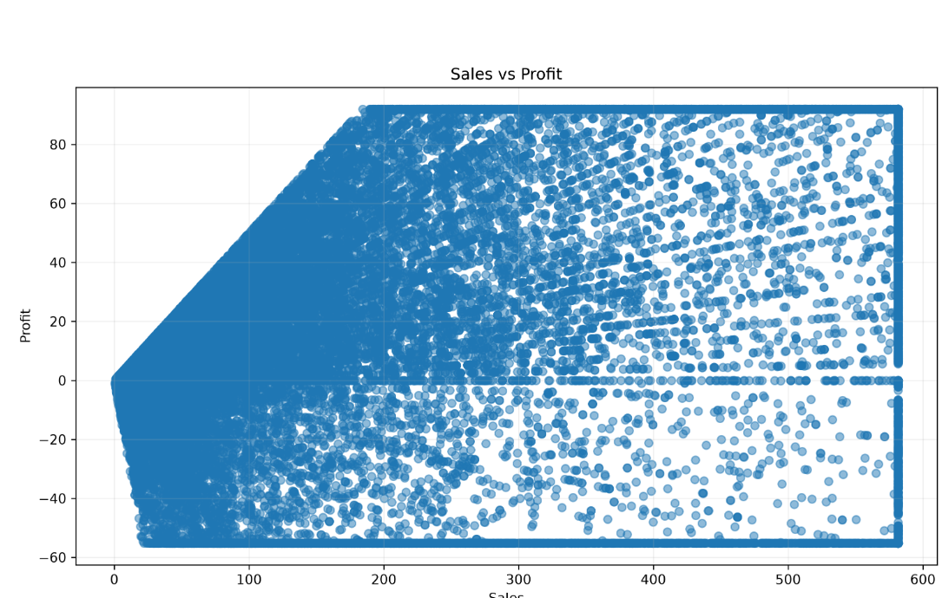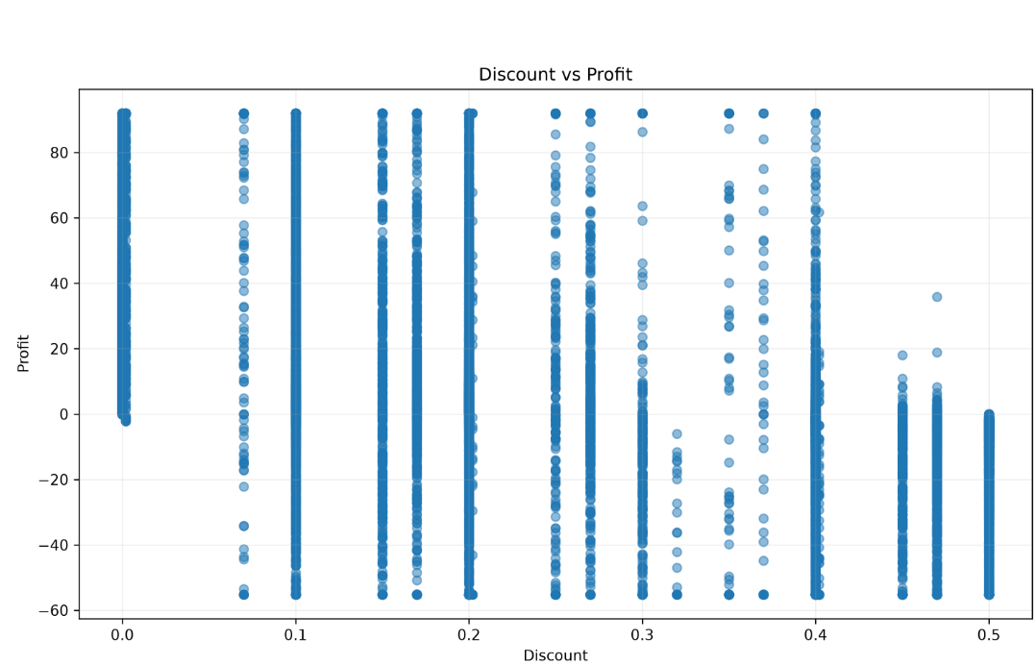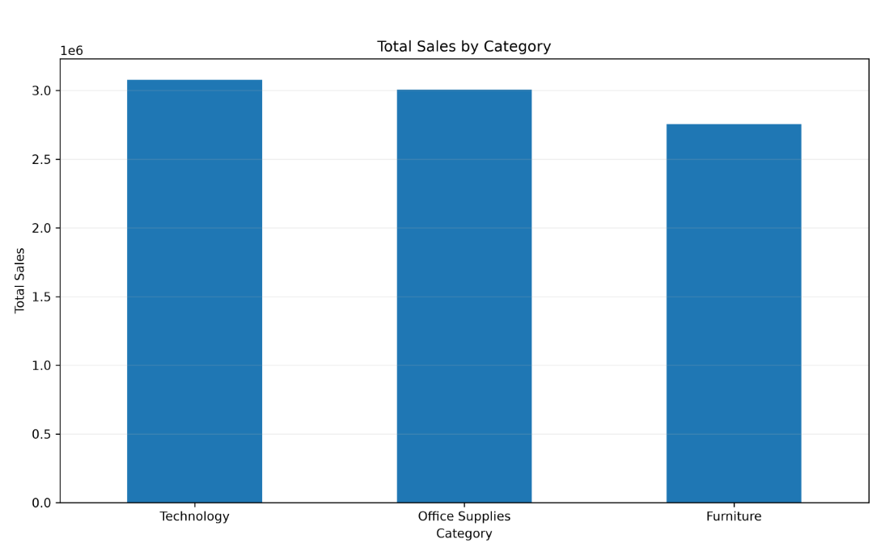
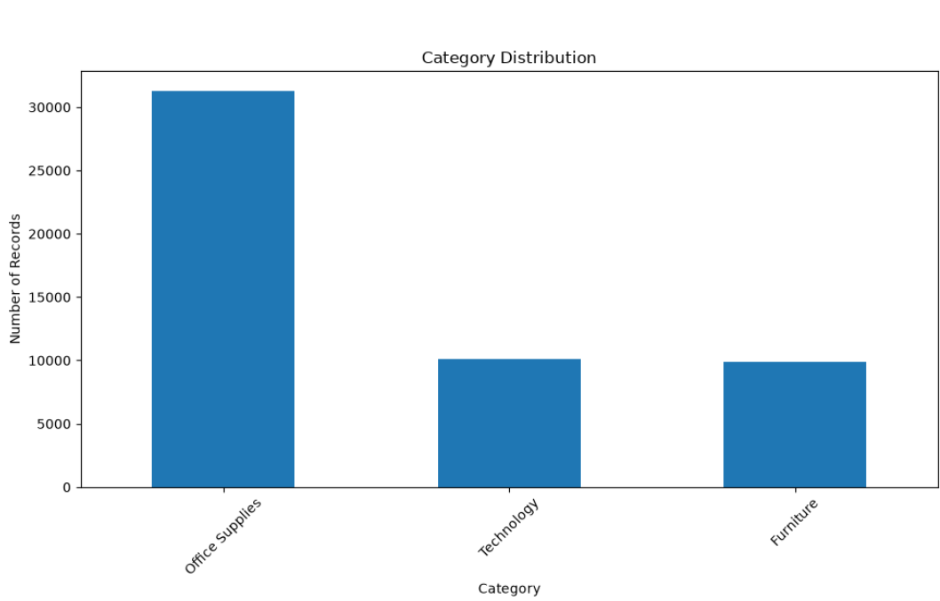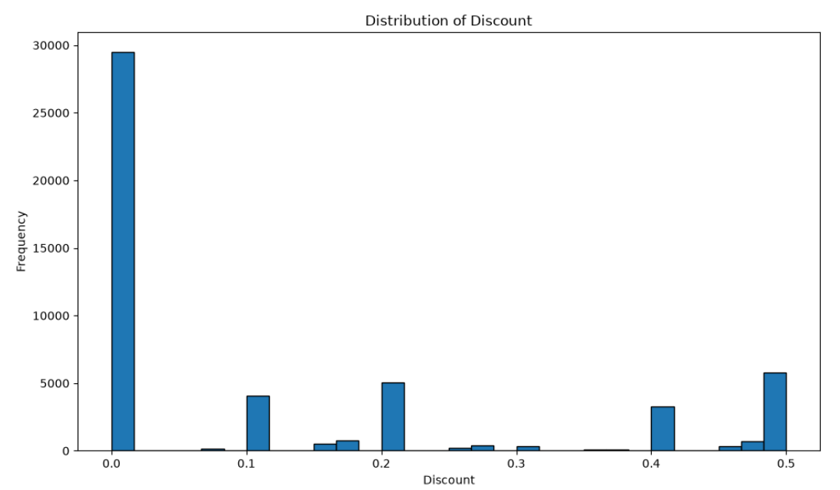
Fig. 2.
3.5 Proposed Model(s) and Baselines
Four regression algorithms were implemented for sales prediction. A baseline model and three tree-based approaches were selected to compare linear and nonlinear learning capabilities.
- Linear Regression was included as the baseline regression algorithm. The algorithm uses a linear function to model the relationship between the input and the output. The simplicity of the model is what makes it useful as a benchmark.
- Decision Tree Regressor
- The reason for including Decision Tree Regression algorithm is that it is capable of modeling nonlinear relations with decision rules. Decision tree algorithms are specifically suitable for heterogeneous data sets.
- Random Forest Regressor
- The technique of Random Forest Regression involves building the predictions from several decision trees. The process may lower the variance of the model in comparison with using only one decision tree. Breiman developed Random Forests as an approach to ensemble learning with the use of randomized decision trees. [1] 

- XGBoost Regressor
- The algorithm XGBoost was selected among gradient boosting models. It builds decision trees in a sequential manner to correct the errors made by the previous trees. XGBoost was invented by Chen and Guestrin.
3.6 Algorithmic / Mathematical Formulation
3.6.1 Linear Regression
The Linear Regression model can be represented as:
$$\begin{matrix} & \hat{y}=β_{0}+β_{1}x_{1}+β_{2}x_{2}+⋯+β_{p}x_{p} & & \text{(1)}\end{matrix}$$
where:
- $\hat{y}$represents predicted sales.
- $β_{0}$represents the intercept.
- $β_{i}$represents the coefficient associated with feature $x_{i}$.
- $p$represents the number of input features.

3.6.2 Mean Squared Error Objective
The regression models minimize prediction error using loss functions related to the difference between actual and predicted values.
$$\begin{matrix} & MSE=\frac{1}{n}\sum_{i=1}^{n}{(}\left.y_{i}-\hat{y_{i}}{\left.)\right.}^{2}\right. & & \text{(2)}\end{matrix}$$
where $y_{i}$represents the actual sales value and $\hat{y_{i}}$represents the predicted sales value.

3.6.3 Random Forest Prediction
For an ensemble containing $B$regression trees, the Random Forest prediction can be represented as:
$$\begin{matrix} & \hat{y}=\frac{1}{B}\sum_{b=1}^{B}{T_{b}}\left(x\right) & & \text{(3)}\end{matrix}$$
where $T_{b}\left(x\right)$is the prediction of the $b^{th}$decision tree.

3.6.4 K-Means Objective Function
K-Means clustering minimizes the within-cluster sum of squared distances:
$$\begin{matrix} & J=\sum_{k=1}^{K}{\sum_{x_{i}∈C_{k}}{∥}}x_{i}-μ_{k}∥^{2} & & \text{(4)}\end{matrix}$$
where:
- $K$is the number of clusters.
- $C_{k}$is cluster $k$.
- $x_{i}$is a customer observation.
- $μ_{k}$is the centroid of cluster $k$.

3.6.5 Mean Absolute Error
$$\begin{matrix} & MAE=\frac{1}{n}\sum_{i=1}^{n}{∣}y_{i}-\hat{y_{i}}∣ & & \text{(5)}\end{matrix}$$

3.6.6 Root Mean Squared Error
$$\begin{matrix} & RMSE=\sqrt{\frac{1}{n}\sum_{i=1}^{n}{(}\left.y_{i}-\hat{y_{i}}{\left.)\right.}^{2}\right.} & & \text{(6)}\end{matrix}$$

3.6.7 Coefficient of Determination
R2=1−∑i=1n​(yi​−yˉ​)2∑i=1n​(yi​−yi​^​)2​
4. EXPERIMENTAL SETUP
4.1 Hardware and Software
There is no need for specialized hardware, and the system will run on a standard PC.
Software:
The following software was used:
Python
NumPy
Pandas
Matplotlib
Seaborn
Scikit-learn
XGBoost
MySQL
MySQL Workbench
Microsoft Power BI
Jupyter Notebook/Visual Studio Code
Git and GitHub

According to the project roadmap, the following project technologies were identified: Python, Jupyter/VS Code, NumPy, Pandas, Matplotlib, Seaborn, Scikit-learn, MySQL, MySQL Workbench, Power BI, Git, and GitHub.
Hardware:
It was sufficient to use a standard PC with enough memory and storage to process 51,290 records of transactions. There is no need for GPU or any other specialized hardware for conducting experiments.
4.2 Dataset Split / Design
The number of data records in the Global Superstore database is 51,290.
The split ratio for the regression tests was 80:20.
Dataset Portion Number of Records
Complete Dataset 51,290
Training Dataset 41,032
Testing Dataset 10,258
The training dataset was utilized for regression model fitting, whereas the testing dataset was used for performance evaluation of the model.
The same test dataset was used for comparison between Linear Regression, Decision Tree, Random Forest, and XGBoost under the current experimental setup.
The customer segmentation process started with creation of customer level features and clustering using K-Means method. Different cluster numbers from K = 2 to K = 6 were tested based on the Silhouette Score.
4.3 Hyperparameter Configuration
The regression models were implemented using the configurations used in the project experiment.
Model | Main Configuration
Linear Regression | Standard Linear Regression
Decision Tree | Maximum depth = 12
Random Forest | 150 estimators; maximum depth = 15
XGBoost | 300 estimators; learning rate = 0.05; maximum depth = 6; subsample = 0.8; column sampling = 0.8
K-Means | K values from 2 to 6 evaluated
The configurations were selected to provide a comparison between a simple linear baseline, an individual decision tree, an ensemble of trees, and a gradient-boosting approach.
For K-Means, the number of clusters was not fixed in advance. Instead, multiple values of $K$were evaluated using the Silhouette Score.
4.4 Validation Strategy
The regression models were validated by means of the 80:20 hold-out validation strategy.
The training dataset included 41,032 observations, and the testing dataset included 10,258 observations.
The performance of models was assessed based on the test dataset using such metrics as MAE, RMSE, and R².
In case of customer segmentation, K-Means model with cluster configuration varying from two to six clusters was validated using the Silhouette Score metric.
Neither repeated k-fold cross-validation nor bootstrap validation was employed in this experiment. Hence, the results presented are obtained in the context of hold-out test set only. ]
4.5 Evaluation Metrics
4.5.1 Mean Absolute Error
- Mean Absolute Error measures the average absolute difference between actual and predicted sales.
- $MAE=\frac{1}{n}\sum_{i=1}^{n}{∣}y_{i}-\hat{y_{i}}∣$
- A lower MAE indicates smaller average prediction errors.
- MAE was selected because it provides an easily interpretable measure of the typical prediction error.

- 4.5.2 Root Mean Squared Error
- RMSE measures the square root of the average squared prediction error.
- $RMSE=\sqrt{\frac{1}{n}\sum_{i=1}^{n}{(}\left.y_{i}-\hat{y_{i}}{\left.)\right.}^{2}\right.}$
- A lower RMSE indicates better predictive performance.
- RMSE was included because squaring the errors gives greater influence to larger prediction errors, which is relevant when unusually large sales-prediction errors need to be detected.

- 4.5.3 R² Score
- R² measures the proportion of variance in the target variable explained by the model.
- $R^{2}=1-\frac{\sum{(}\left.y_{i}-\hat{y_{i}}{\left.)\right.}^{2}\right.}{\sum{(}\left.y_{i}-\overline{y}{\left.)\right.}^{2}\right.}$
- A higher R² indicates that the model explains a larger proportion of variation in sales.
- R² was selected to provide a standardized measure for comparing the four regression models.

- 4.5.4 Silhouette Score
- The Silhouette Score measures the separation and compactness of clusters.
- For an observation $i$:
- $\begin{matrix} & s\left(i\right)=\frac{b\left(i\right)-a\left(i\right)}{max⁡\left(a , \left(i\right)b\left(i\right)\right)} & & \text{(8)}\end{matrix}$
- where:
- $a\left(i\right)$represents the average distance between observation $i$and other observations in the same cluster.
- $b\left(i\right)$represents the lowest average distance between observation $i$and observations belonging to another cluster.
- A higher Silhouette Score indicates better-defined clusters.
- The metric was selected because customer segmentation requires both high within-cluster similarity and good separation between clusters.
5. RESULTS
This section contains the findings that have been derived empirically through the Global Superstore experiment that has been conducted. The findings contain the performance of the sales prediction, customer segmentation, RFM analysis, CLV, correlation analysis, scenario analysis, and Power BI dashboards.
5.1 Overall Performance
performance achieved by Linear Regression was an R² of 0.6830. On the other hand, Decision Tree and Random Forest had R² performances of 0.8682 and 0.8902, respectively. However, XGBoost produced the best R² of 0.9116, along with the best MAE of 32.8537 and the best RMSE of 57.0368.
These outcomes show that the tree-based algorithms performed better in identifying nonlinear patterns in the retail transaction data than the linear algorithm under the experimental framework used.
5.2 Model / Method Comparison
Table 2 compares the performance of regression models used for retail sales and prediction .

Method | Metric A | Metric B | Notes
Linear Regression | 78.7126 | 108.0159 | Baseline linear model
Decision Tree | 36.8939 | 69.6571 | Captures nonlinear relationships
Random Forest | 34.3853 | 63.5656 | Ensemble tree mode
XGBoost | 32.8537 | 57.0368 | Gradient-boosting model
Table 2.Performance comparison of regression models for retail sales prediction.
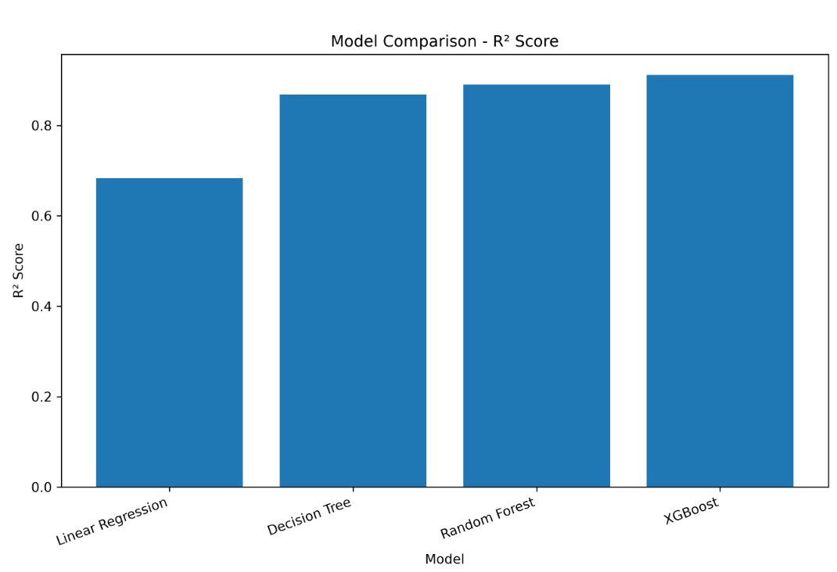
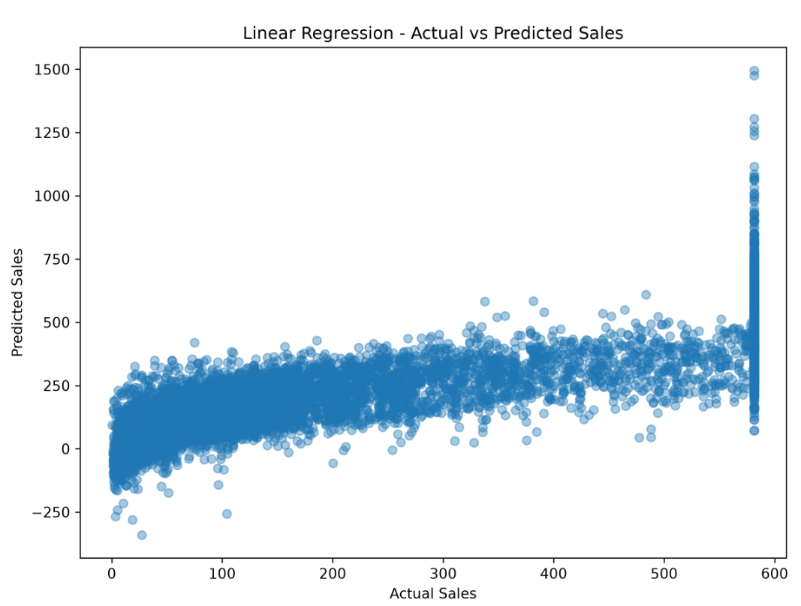
Fig. 3.
5.3 [ Additional Result Sub-section, e.g., Error/Confusion Analysis ]
K-Means clustering was evaluated using values of $K$ranging from 2 to 6.
Number of Clusters | Silhouette Score
2 | 0.666635
3 | 0.554768
4 | 0.506601
5 | 0.355589
6 | 0.353201
Table 3. Silhouette Score comparison for different K-Means cluster configurations.
The highest Silhouette Score is obtained when $K=2$, with a value of 0.666635. The score decreases as the number of clusters increases. Therefore, the two-cluster configuration was selected for the implemented customer segmentation.
5.4 [ Additional Result Sub-section, e.g., Feature/Factor Importance ]
RFM analysis was performed using Recency, Frequency, and Monetary characteristics.
Customer Value | Customers | Total Sales | Total Profit | Average RFM Score
High Value | 515 | 5,484,204 | 578,661 | 13.23
Medium Value | 461 | 2,510,516 | 269,763 | 9.59
Low Value | 614 | 845,582 | 79,537 | 5.01

6. DISCUSSION
6.1 Interpretation of Findings
From the experiment, it is clear that model selection has a significant impact on the accuracy of sales prediction. Linear Regression gives a good baseline but gives relatively high error predictions. Tree-based algorithms give better results as they are able to capture nonlinear relationships and interactions between retail variables.

Decision Tree brings down the MAE to 36.8939 from 78.7126. Random Forest further lowers the MAE to 34.3853. XGBoost provides the lowest MAE of 32.8537 and the lowest RMSE of 57.0368.
The increase in R² value from 0.6830 in Linear Regression to 0.9116 in XGBoost shows that the developed XGBoost model accounts for more variance of the observations than other models.
6.2 Comparison With Previous Studies
results are in line with the general trend in the field of retail analytics, where machine learning techniques are employed to predict sales and segment customers.
Tang studied retail demand forecasting and customer segmentation using machine learning and RFM techniques, showing the usefulness of the combination of prediction and customer analytics. [5]
Kasem et al. explored customer profiling, segmentation, and sales prediction based on artificial intelligence, confirming the potential of prediction and customer analytics combination. [6]
Wang et al. suggested dynamic customer segmentation through LRFMS and multivariate time series clustering, highlighting the significance of customer behavior-based segmentation. [7]
6.3 Theoretical Implications
The findings demonstrate that retail analytics can benefit from combining several analytical perspectives rather than depending on a single model.
Sales prediction provides a predictive perspective, while clustering provides a behavioral perspective. RFM provides customer-value information, and CLV provides a financial perspective.
The integration of these approaches provides a more comprehensive representation of retail performance.
6.4 Practical Implications
The proposed framework can support retail organizations in several areas.
Sales prediction can assist with planning and forecasting.
Customer segmentation can help identify groups with different purchasing behavior.
RFM analysis can support customer-value identification.
CLV analysis can help identify customers with greater historical value.
Product analysis can help identify products and categories with different sales and profit characteristics.
Regional analysis can identify differences between geographic markets.
Power BI dashboards can make these results accessible through interactive business intelligence.
The Business Recommendation Engine can further convert analytical outputs into business-oriented recommendations.
6.5 Unexpected Findings
The first noteworthy thing is the discrepancy between the K-Means clusters of customers and the RFM segments.
While K-Means creates two clusters using customer-level behavioral variables, RFM creates three segments of customers according to their value.
This illustrates that various approaches allow capturing various aspects of customer behavior. Consequently, these results should not be considered to mean the same classification of customers but rather to complement each other.
The second thing is that Office Supplies earned more profit than Technology although Technology made more sales.
7. LIMITATIONS
- Evaluation of the regression models involved a one-time hold-out test using an 80:20 ratio instead of cross-validation.
- The stated predictions for this task are based on the Global Superstore data set and will not necessarily apply to other retail data sets.
- The data set is from past transactions in the retail business and does not necessarily reflect present conditions.
- Present implementation of CLV gives the customer’s historical value but not a probabilistic future lifetime model.
- The sensitivity analysis is model-based and hence does not demonstrate causality.]
8. CONCLUSION AND FUTURE WORK

In this research work, a Retail Sales Analytics and Customer Intelligence Framework that uses Data Preprocessing, Exploratory Data Analysis, Feature Engineering, Machine Learning, Customer Segmentation, RFM Analysis, Customer Lifetime Value, SQL, Scenario Analysis, and Power BI was developed.

Four different regression models were tested for sales forecasting purposes. In particular, XGBoost scored an MAE of 32.8537, RMSE of 57.0368, and R² of 0.9116 on the built test dataset. As for K-Means Clustering, its best Silhouette Score on two clusters is 0.666635.
The customer intelligence approach delivers complementary data through K-Means clustering, RFM analysis, and CLV analysis. Moreover, Power BI dashboards deliver an interactive environment for studying sales, products, customers, CLV, scenarios, and business-related information.
The novel idea of the Business Recommendation Engine is the main innovation of the research work
Future Work:
Future work will focus on the following improvements:
- Implementing repeated k-fold and temporal cross-validation for more robust model evaluation.
- Testing the framework on additional Superstore benchmark datasets.
- Integrating SHAP and LIME for explainable machine learning.
- Developing a fully automated Business Recommendation Engine.
- Implementing advanced Customer Lifetime Value prediction.
- Adding demand and inventory forecasting.
- Developing a Streamlit-based deployment interface.
- Investigating real-time retail data integration.
DECLARATIONS
Funding
No funding was received for the completion of this research project from any external source. It was done as an academic project using freely available retail data.
Conflict of Interest
The authors declare that there is no conflict of interest related to this research.
Ethics Statement
study is based on publicly available sales data and does not require any interaction with individuals. No personally identifiable information about customers was knowingly used in the study.
Data Availability
The research is based on Global Superstore data collected from a publicly accessible source at Kaggle. The project roadmap also mentions publicly accessible benchmark datasets of Superstores from Kaggle and Tableau.
Author Contributions
J. Madhura: Statistical analysis, visualization, customer analytics, and dashboard development.
R. Lokesh: Machine-learning implementation, model evaluation, customer segmentation, and scenario analysis.
G. Charan: SQL/database integration, Power BI integration, documentation, and presentation.

Acknowledgements
Here, the authors would like to extend their sincere thanks to Dr. K. Swapnika, Project Guide, for the useful guidance, technical advice, and continuous support in carrying out this research project.
The authors also thank the Department of Computer Science and Engineering and K L University for the conducive atmosphere that helped in carrying out this research project. ]

REFERENCES
[1] L. Breiman, “Random Forests,” Machine Learning, vol. 45, no. 1, pp. 5–32, 2001, doi: 10.1023/A:1010933404324.
[2] T. Chen and C. Guestrin, “XGBoost: A Scalable Tree Boosting System,” in Proceedings of the 22nd ACM SIGKDD International Conference on Knowledge Discovery and Data Mining, San Francisco, CA, USA, 2016, pp. 785–794. 
[3] J. MacQueen, “Some Methods for Classification and Analysis of Multivariate Observations,” in Proceedings of the Fifth Berkeley Symposium on Mathematical Statistics and Probability, Berkeley, CA, USA, 1967, pp. 281–297. The historical origin of the K-means procedure is commonly attributed to MacQueen's 1967 work. 
[4] F. Pedregosa et al., “Scikit-learn: Machine Learning in Python,” Journal of Machine Learning Research, vol. 12, pp. 2825–2830, 2011.
[5] J. Tang, “Unlocking Retail Insights: Predictive Modeling and Customer Segmentation Through Data Analytics,” Journal of Theoretical and Applied Electronic Commerce Research, vol. 20, no. 2, 2025. 
[6] M. S. Kasem, M. Hamada, and I. Taj-Eddin, “Customer Profiling, Segmentation, and Sales Prediction Using AI in Direct Marketing,” Neural Computing and Applications, vol. 36, pp. 4995–5005, 2024.
[7] S. Wang, L. Sun, and Y. Yu, “A Dynamic Customer Segmentation Approach by Combining LRFMS and Multivariate Time Series Clustering,” Scientific Reports, vol. 14, 2024.
[8] J. M. John, O. Shobayo, and B. Ogunleye, “An Exploration of Clustering Algorithms for Customer Segmentation in the UK Retail Market,” Data, vol. 9, no. 10, 2024.
[9] M. T. Ribeiro, S. Singh, and C. Guestrin, “Why Should I Trust You?: Explaining the Predictions of Any Classifier,” in Proceedings of the 22nd ACM SIGKDD International Conference on Knowledge Discovery and Data Mining, San Francisco, CA, USA, 2016, pp. 1135–1144.
[10] S. M. Lundberg and S.-I. Lee, “A Unified Approach to Interpreting Model Predictions,” in Advances in Neural Information Processing Systems, vol. 30, 2017.
.

